Monthly Report 6

- Date of Report: 15/1/2025
- Student ID - Name: 21110241 Issam Awamleh
- Major: Cybersecurity
- Company: CyberShield Academy - JODDB
- Department: Cybersecurity
- Industry Mentor: Abdullah al masri, Yousef halaseh
- Apprenticeship Mentor: Shareef Shargawi
- Working days/hours: 8-2 Sunday–Thursday
Your report must cover these topics:
Your role and responsibilities this month (+ evidence):
My role was in management sector by developing a website for the instructors of the academy and complete marching on my self career development path by getting CWSE( certified web security expert).
Evidances:
My tasks that Assigned for me
- Any problems/challenges, and how did you overcome them?
- Getting along with kind of tasks that not related to my major and discovering or practicing web development.
- Any training courses you attended during the apprenticeship, whether you opted for them independently or through the employer.
  - Name of the course: CWSE
  - Main Topics: web exploitation
  - Copy of certification: in progress.
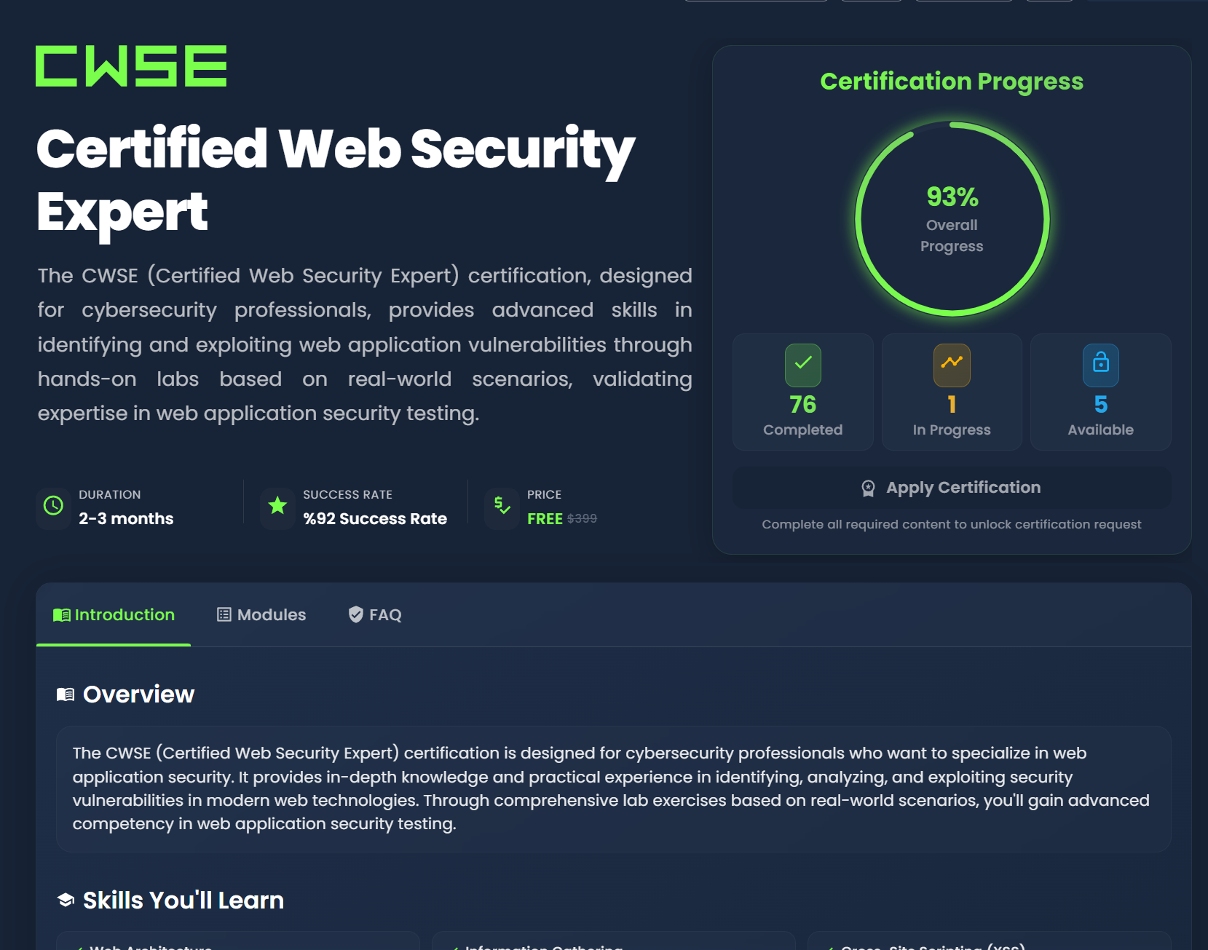

- What software/tools did you use?
- Kali Linux, Nmap, my Trello, Microsoft Word, Microsoft excel, antigravity, SQLite DB, VS code, hackviser, burp suite and VPN.
- Technical and non-technical skills
- Teamwork, Brain storming, Time Management, analytical thinking,challenges, planning, web development , multi-tasking ,VPN, using AI in web development, innovation and documentation .
- Did you work on the National Occupational Standards (NOSs)?
  - How many NOSs did you complete out of 5? 1/5
  - List of NOSs (Number (URN) – Name of NOS):
1_ TECDT611403 - Respond to and Recover from OT Cybersecurity Incidents
- Events/Conferences you participated
- I didn’t participate in any event this month.
- Your Plan for Next Month.
- Doing test plan for the website.
- Having a certificate called red teaming using AI.
- Finished the CWSE and get the certification.

